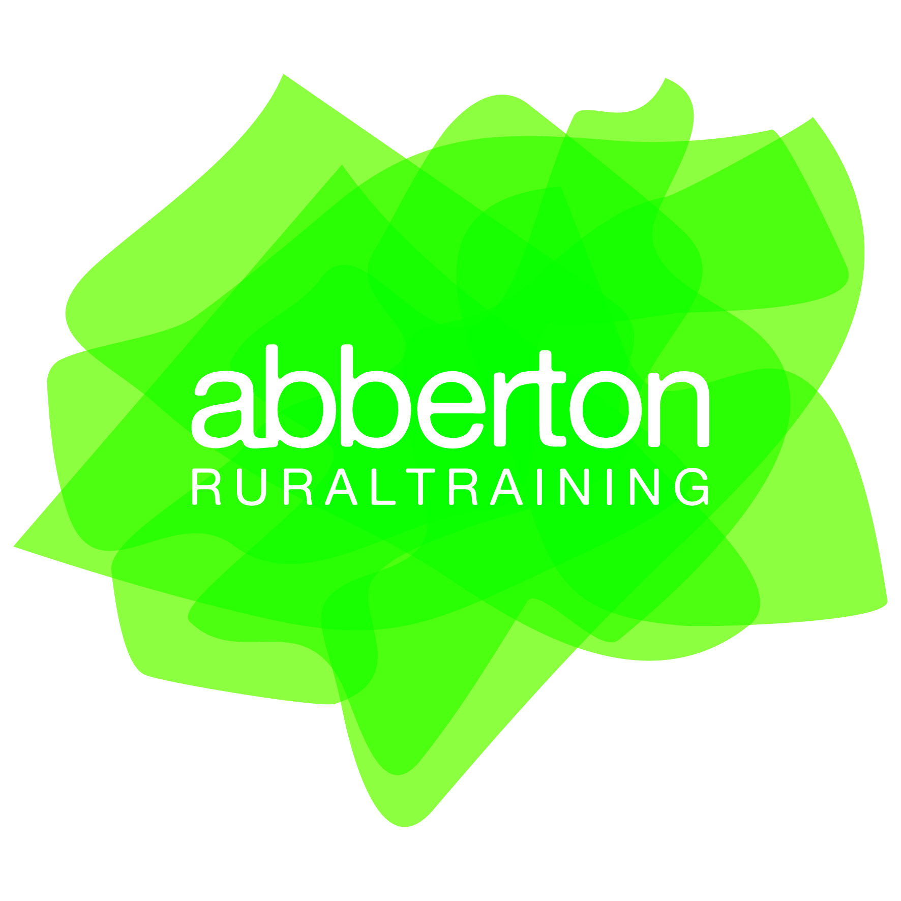
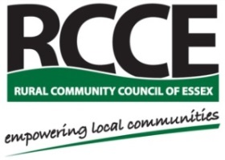

Abberton Rural Training - Essex Rural Skills Project Officer
35 hours per week to December 2019
Salary: £23,000 to £25,000 p.a. plus pension

Established in 2014, Abberton Rural Training (ART) is a unique programme providing training in rural skills to disadvantaged people. ART has been awarded a 3-year grant from the Big Lottery Fund and the European Social Fund (ESF) to deliver a new and innovative Essex Rural Skills Project.

We are now looking for an Essex Rural Skills Project Officer to support the ART Programme Manager in delivering this new project. The post will be based at the Wormingford Community Education Centre, CO6 3AT.

The role will require experience of working with individuals with special educational needs (SEN), mental health problems, learning difficulties and/or disabilities.

Applicants will be empathetic and possess effective leadership and team-working skills as well as an ability to multi-task, working to tight deadlines.

The appointment will be subject to a DBS check.

For an application pack please email Beverly Davies at Beverly.davies@essexrcc.org.uk or by phone on 01376 574339.

Application deadline: Midday, Tuesday 2nd May
Interviews held: Week beginning 15th May

Rural Community Council for Essex (RCCE) is the accountable body for the ART project. Rural Community Council of Essex has over 85 years’ experience of supporting communities and social enterprises in rural Essex. RCCE Registered Company No. 4609624 Registered Charity No. 1097009

